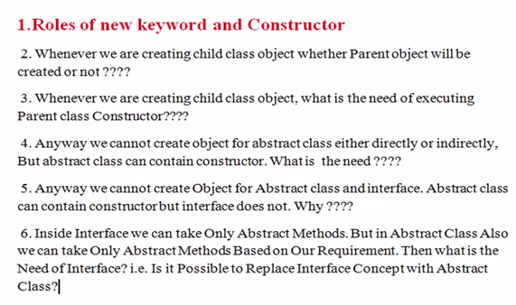

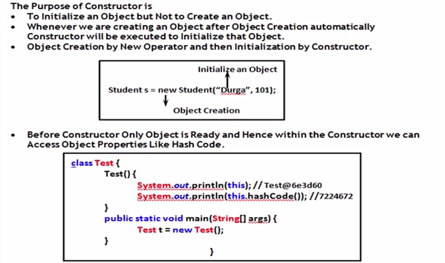

1. **Roles of New and Constructor**

Student s=new Student(“anbu”,1001)

From above line,

* New operator is responsible to create an object, at that time instance variables of that object have default values. (null for object type, 0 for int, 0.0 for float, etc.,)
* Once object is created, constructor is responsible to initialize that object or object instance variables

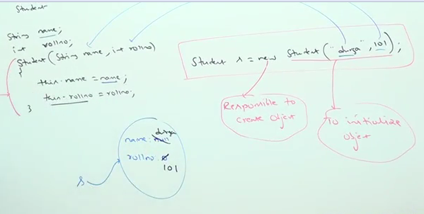

1. **Whenever we are creating child class object whether Parent object will be created or not?**

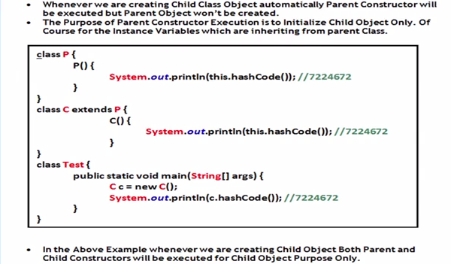

1. **Whenever we are creating child class object, what is the need of executing parent class Constructor?**

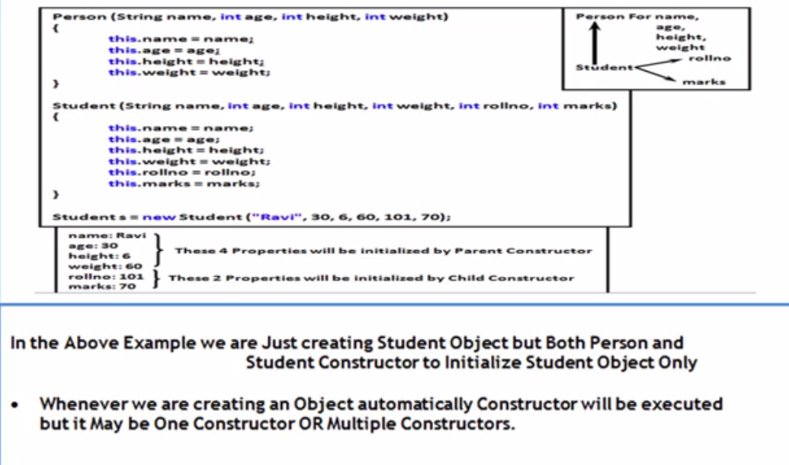

Example:



* Whenever we are creating child class object, automatically parent class constructor will be executed to perform initialization for the instance variable which are inheriting from parent.

1. **Anyway we cannot create object for abstract class either directly or indirectly. But abstract class can contain constructor. What is the need????**

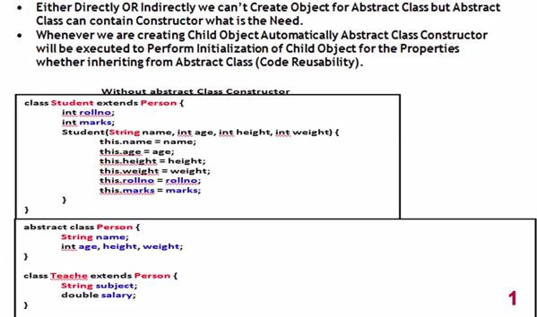

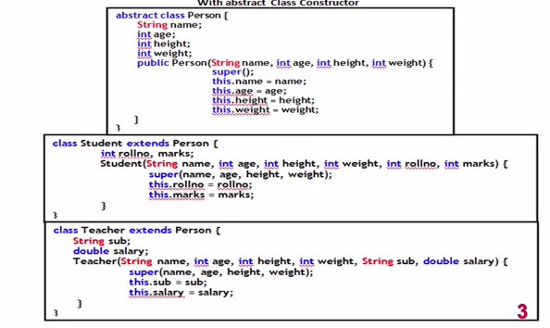

1. **Anyway we cannot create Object for Abstract class and Interface. Abstract class can contain constructor but interface does not. Why ???**

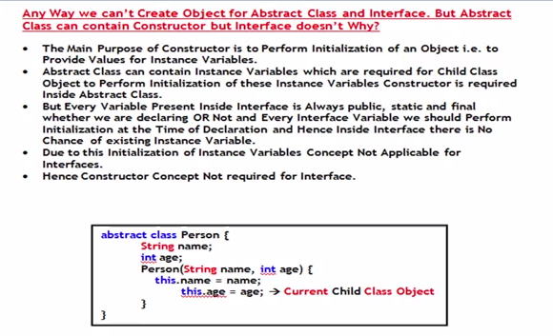

1. **Inside Interface we can take only Abstract methods. But In Abstract class also we can take only abstract methods based on our requirement. Then what is the need of Interface? i.e. Is it possible to replace interface concept with abstract class???**

